**Electromagnetic Radiation:**

Electromagnetic radiation refers to the propagation of energy through space in the form of oscillating electric and magnetic fields. This radiation spans a wide range of frequencies, wavelengths, and energies, collectively known as the electromagnetic spectrum. It includes familiar phenomena like radio waves, microwaves, infrared radiation, visible light, ultraviolet radiation, X-rays, and gamma rays.

Key properties of electromagnetic radiation include:

1. **Frequency and Wavelength**: Frequency (f) and wavelength (λ) are inversely proportional to each other, as determined by the equation: c=fλ, where c is the speed of light in a vacuum (3×1083×108 meters/second). As frequency increases, wavelength decreases, and vice versa.
2. **Speed**: Electromagnetic radiation travels at the speed of light in a vacuum, denoted as cc. This speed is approximately 3×1083×108 meters per second.
3. **Quantum Nature**: Electromagnetic radiation exhibits both wave-like and particle-like behavior. Each photon, the fundamental particle of electromagnetic radiation, carries a specific amount of energy proportional to its frequency, as described by the equation E=hf, where E is the energy of the photon, h is Planck's constant, and f is the frequency.
4. **Interaction with Matter**: Electromagnetic radiation interacts with matter in various ways depending on its frequency and the nature of the material. This interaction can include absorption, reflection, transmission, or scattering.
5. **Spectrum**: The electromagnetic spectrum is divided into different regions based on frequency or wavelength. Each region has unique properties and applications. For example:
   * Radio waves are used for communication (e.g., radio and television broadcasting).
   * Microwaves are utilized in microwave ovens, communication technologies, and radar.
   * Infrared radiation is associated with heat and is used in thermal imaging and remote sensing.
   * Visible light is the portion of the spectrum visible to the human eye and is responsible for vision.
   * Ultraviolet radiation has applications in sterilization, fluorescence, and astronomy.
   * X-rays are used in medical imaging and industrial applications for inspection and quality control.
   * Gamma rays are employed in medical treatments (e.g., radiation therapy) and industrial applications (e.g., sterilization of medical equipment).

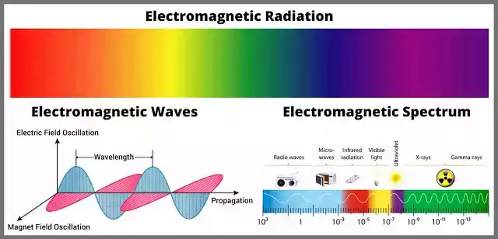

Fig: Electromagnetic Radiation

One practical example of electromagnetic radiation is the use of Wi-Fi technology. Wi-Fi operates using radio waves, which are a type of electromagnetic radiation. Devices such as smartphones, laptops, and routers emit and receive radio waves to establish wireless internet connections. These radio waves propagate through space, allowing users to access the internet without the need for physical cables.

**Prism:**

**A** prism is a transparent geometric solid typically made of glass or plastic, characterized by two parallel and congruent polygonal faces connected by several parallelogram-shaped lateral faces. Prisms are renowned for their ability to refract light, bending it as it passes through due to the change in speed between different media. This refraction causes light to separate into its constituent colors, a phenomenon known as dispersion, which is often demonstrated by the creation of a rainbow. Prisms are widely used in optics, serving as key components in devices such as cameras, binoculars, and spectrometers. They are also utilized in educational settings to illustrate principles of light and color. Beyond their scientific applications, prisms are sometimes employed for decorative purposes in architecture and design, adding aesthetic appeal and light manipulation to structures. Overall, prisms play a fundamental role in understanding and harnessing the behavior of light in various fields of science, technology, and art.

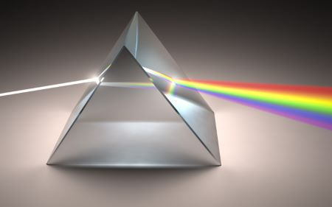

**Sunlight:**

Sunlight has profound effects on chemistry, influencing numerous chemical processes on Earth’s surface and in the atmosphere. Here are some effects of Sunlight:

1. **Photosynthesis**: Sunlight is essential for photosynthesis, the process by which green plants, algae, and some bacteria convert carbon dioxide and water into glucose and oxygen, using sunlight as an energy source. This process sustains life on Earth by producing oxygen and serving as the foundation of the food chain.
2. **Ozone Formation and Destruction**: Sunlight plays a crucial role in both the formation and destruction of ozone (O3) in the atmosphere. In the stratosphere, ultraviolet (UV) radiation from the sun splits oxygen molecules (O2) into two oxygen atoms, which then combine with other oxygen molecules to form ozone. However, ozone is also susceptible to degradation by UV radiation, leading to the creation of oxygen molecules.
3. **Photodissociation**: Sunlight can break chemical bonds through a process called photodissociation. For example, in the atmosphere, sunlight can break apart nitrogen dioxide (NO2) molecules into nitrogen monoxide (NO) and an oxygen atom. This process has implications for air quality and the formation of pollutants like smog and ozone.
4. **Photocatalysis**: Certain chemical reactions are facilitated or accelerated by sunlight through photocatalysis. For instance, in environmental remediation, photocatalytic materials such as titanium dioxide (TiO2) are used to degrade pollutants in water and air under sunlight exposure.
5. **Photochemical Reactions**: Sunlight triggers various photochemical reactions in the atmosphere, leading to the formation of secondary pollutants such as ozone, nitrous oxide (N2O), and volatile organic compounds (VOCs). These reactions contribute to atmospheric chemistry, air quality, and climate change.
6. **Solar Energy Conversion**: Sunlight serves as an abundant source of energy for solar technologies, including photovoltaic cells and solar thermal systems. Photovoltaic cells convert sunlight directly into electricity, while solar thermal systems use sunlight to heat fluids for electricity generation or heating applications.
7. **Effect on Materials**: Sunlight can degrade materials over time through processes like photodegradation and photooxidation. Ultraviolet radiation in sunlight can break chemical bonds in materials such as plastics, paints, and dyes, leading to fading, discoloration, and deterioration.

**Rainbow:**

Rainbows form when sunlight interacts with water droplets suspended in the atmosphere. The process begins with sunlight, which appears white to the human eye but is composed of a spectrum of colors ranging from red to violet. When sunlight encounters a water droplet, it undergoes refraction, bending as it enters the droplet due to the change in speed between air and water. This bending of light causes the sunlight to disperse into its constituent colors, as different wavelengths of light refract by different amounts.

As the dispersed sunlight travels through the water droplet, it undergoes internal reflection off the inner surface of the droplet. Some of this internally reflected light exits the droplet, creating a cone-shaped beam of light. The angle at which this light exits the droplet depends on the

wavelength of the light, with shorter wavelengths (blue and violet) refracting at larger angles than longer wavelengths (red and orange).

Several factors influence the appearance of rainbows, including the size of the water droplets, the angle of sunlight, and the observer's position. Larger water droplets tend to produce more vivid rainbows with broader bands of color, while smaller droplets may result in fainter rainbows. The angle of sunlight relative to the observer determines the height and visibility of the rainbow, with lower sun angles producing higher and more pronounced rainbows.



Fig: Rainbow

**Wavelength:**

Wavelength is a fundamental property of electromagnetic radiation, which encompasses a wide range of energy waves traveling through space at the speed of light.

Wavelength (λ) is defined as the distance between two successive points of a wave that are in phase with each other. For electromagnetic radiation, this corresponds to the distance between consecutive crests or troughs of the wave. Wavelength is usually measured in meters (m) or multiples thereof, such as nanometers (nm) or micrometers (µm).

The electromagnetic spectrum encompasses a broad range of wavelengths, divided into different regions based on their frequency and energy. These regions include radio waves, microwaves, infrared radiation, visible light, ultraviolet radiation, X-rays, and gamma rays. Each region has unique properties and applications, ranging from communication and imaging to medical diagnosis and treatment. The behavior of electromagnetic radiation is influenced by its wavelength. For example, longer-wavelength radiation, such as radio waves and microwaves, can penetrate materials more easily than shorter-wavelength radiation, such as X-rays and gamma rays. Atoms and molecules interact with electromagnetic radiation in a wavelength-dependent manner. When electromagnetic radiation is absorbed or emitted by atoms or molecules, it results in characteristic spectral lines in the electromagnetic spectrum. These lines correspond to specific wavelengths associated with electronic or vibrational transitions within the atoms or molecules, providing valuable information about their structure and composition. The human eye perceives different colors based on the wavelengths of light that are absorbed and reflected by objects. For example, a red apple appears red because it reflects red wavelengths of light and absorbs other wavelengths. Understanding the relationship between wavelength and color perception is essential in fields such as art, design, and lighting.

Fig: Wavelength and Color perception